Artificial Intelligence Lab
BSCS [5-A]
FINAL TERM PROJECT REPORT


Submitted By:
- Aymal Ahmad-022
- Muaaz Nazeer-051
- Daniyal Jamil-024

Submitted to:
USMAN ANWAR

BAHRIA UNIVERSITY, LAHORE CAMPUS
DEPARTMENT OF COMPUTER SCIENCES
SELF-DRIVING CAR AI USING NEAT
By Daniyal Jamil, Muaaz Nazeer, Aymal Ahmad
ABSTRACT
This project implements an autonomous self-driving car simulation using the NEAT +GA algorithm. Cars learn to navigate a 2D track using radar sensors without predefined rules or labeled data. Over generations, neural networks evolve to improve steering, speed control, and obstacle avoidance.
INTRODUCTION
Autonomous driving is a major challenge in artificial intelligence. Instead of rule-based or supervised approaches, our project uses neuroevolution, genetic algorithm and some RL to automatically learn driving behavior.
1.1 Background:
Autonomous navigation remains a complex and challenging area of artificial intelligence.
Common approaches are often based either on hand-written rules or supervised machine learning which requires extensive amounts of annotated data. The alternative is the one in which intelligent behaviour can be developed by simulated evolution and genetic algo. The NEAT algorithm also evolves the structure of neural networks as well as the connection weights, beginning with very simple networks and only adding complexity to them as long as it leads to an improvement in performance.

1.2 Problem Statement:
Autopilots of self-driving cars should be able to process information in real time, adapt to changing environments, learn without relying on large, labeled datasets. This project investigates whether NEAT can automatically develop effective vehicle control policies only by using a simple, performance-based fitness function in a simulated racing environment.

1.3 Project Objectives:
This study aims to:
1. Use NEAT algorithm and Genetic algorithm to develop a RL MODEL that is used to navigate a racing simulation of autonomous vehicles.
2. Assess how effective is a distance-based fitness criterion in developing driving behavior.
3. Research the sufficiency of five-radar sensor installation on navigation.
4. Follow and assess the behavioral development across several generations.

FITNESS FUNCTION OF OUR ENTIRE PROJECT (HEART)
Fitness = (Distance Traveled) - (Time Penalty)

LITERATURE REVIEW
NEAT evolves both neural network structure and weights. In evolutionary robotics, such techniques have demonstrated the emergence of complex behavior from simple fitness objectives.

Neuroevolutionary and NEAT:
In 2002 Stanley and Mikulin formulated NEAT to overcome insufficiencies in previous neuroevolutionary. It is characterized by historical markings to ease crossover, speciation to secure new solutions and incremental growth of simple initial networks. As opposed to topologically fixed methods, NEAT adds structural complexity as it is helpful.

METHODOLOGY
Input Layer
The input layer consists of six values: five radar sensor readings and one normalized SPEEDOMETER or basically a speed value.
Neurons
Each car is controlled by a NEAT-evolved neural network that acts as a decision-making unit.
Output Layer and Weights
The network outputs four actions: accelerate, brake, turn left, and turn right. The highest output determines the car’s action.
System Architecture
The system is implemented in Python using Pygame and NEAT-Python. White borders define track boundaries.
[Screenshot Placeholder: Simulation environment with track]
Sensor System / Input:
INPUT 1: LEFT
INPUT 2: LEFT FRONT ( OR LEFT FORWARD)
INPUT 3: RIGHT ( RIGHT FORWARD)
INPUT 4: RIGHT
INPUT 5: FORWARD
INPUT 6: not a sensor but internal logic: SPEEDOMETER

Green radar lines extend up to 300 pixels from the car. These green lines basically serve as input layer, they relay if the barrier ( white pixel detection sir) When a radar hits a white pixel, an obstacle is detected. Through angle calculations using MATH library, the NEAT tells the processing / hidden layer that “ bhai aggay deewar h, left side khali h according to left sensor” so the output will give HIGH WEIGHT VALUE to output LEFT while low weights to RIGHT, SPEED UP AND SPEED DOWN
Causing car to go left.
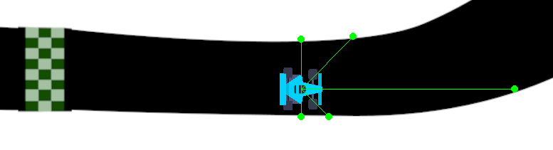

FEATURES
- Persistent AI Memory (Pickle Integration):
  - Save Mechanism: At the end of every simulation run, the neural network data (genomes and weights) is serialized and saved to a binary file named smart_population.pkl.
  - Resume Capability: The system features a LOAD_FROM_SAVE flag. When set to True, the simulation checks for existing data. For example, if a session ends at Generation 5, the next session will seamlessly resume at Generation 6 with all learned behaviors retained.
  - Benefit: This prevents data loss and allows for long-term training of "Super Driver" AI over days or weeks without needing to keep the computer running indefinitely.

Data Visualization & Analytics:
  - Performance Graphs: We utilize the Matplotlib library to automatically generate a detailed line graph at the end of each session.
  - Metrics Tracked: The graph plots "Average Fitness" (general population health) against "Best Fitness" (the top performer).
  - Insight: This visual feedback allows developers to instantly verify if the NEAT algorithm is successfully optimizing the cars or if the population has stagnated.

- Dynamic Map System:
  - The simulation supports 5 interchangeable maps, preventing the AI from "overfitting" (memorizing a specific route).
  - Universal Detection: Because the sensors rely on color-coded collision detection (white borders), the cars can theoretically navigate any map layout provided it adheres to the design standards.
- Optimized Library Integration:
  - OpenCV (cv2): Employed for high-performance video rendering to display the project intro without lagging the main application.
  - NumPy: Utilized for efficient matrix operations and image array handling, essential for the pixel-perfect collision detection.
  - Pygame: Serves as the core engine for rendering the 2D physics, sprites, and handling the real-time game loop

RESULTS
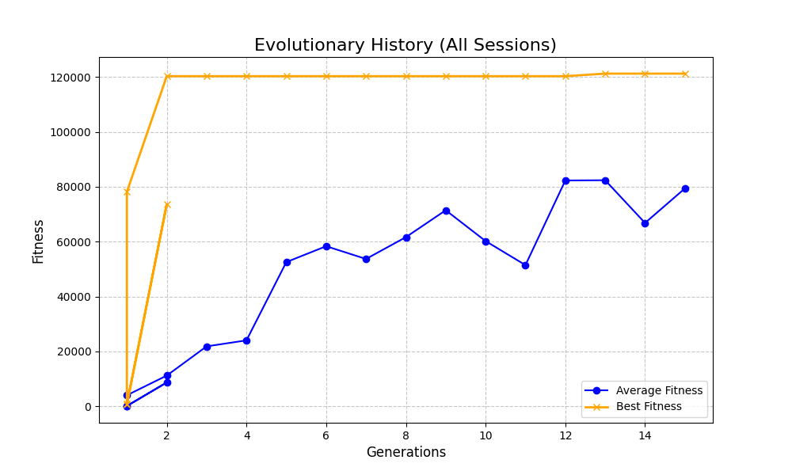
Early generations crash quickly, while later generations show smoother driving and improved control.

As you can see sir, in the above graph, we start from generation 0, in generation 0 our output weights are spawned randomly, meaning no car really knows when to go left, or right, when to speed up or down etc, but through each generation it EVOLVES slowly learning the map through random mutations, luck, and then finally crossover combining the best performing cars, eventually OUR DATA LOOKS LIKE:
TOTAL CARS IN ALL GENERATIONS: 20
Survived gen 0: 1 car survived the first run/ generation with fitness of 10000.
Survived gen 10: 12 cars survived gen 10 with fitness over 60,000. These 12 cars not only survived but drive with good speed, hence, achieving such a high score.
Survived gen 20: 17 cars, but at this point the improvement has decreased, i.e cars have almost reached optimal track performance, and graph climb is slowly starting to slow down now as u can see sir.

EVOLUTIONARY GRAPHS
Fitness data is logged and plotted crc showing average and best fitness across generations.
Generation 1-5 (1 epoch according to our project)
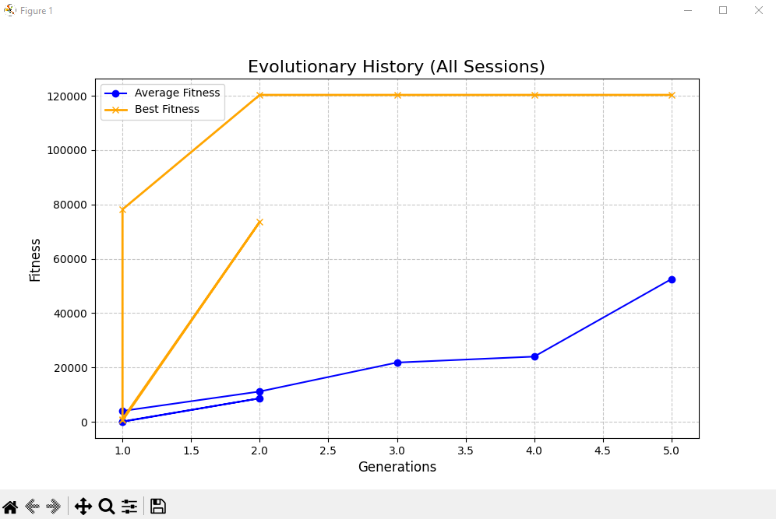

Generation 1 to 5 : many cars crashed straight out and only 1-2 survived first 2 generations, in gen 3 to 5 5- 7 cars managed to survive but were’nt fast so they have low fitness around 10 thousand as we can see in graph

Generation 5-10 (2nd epoch according to our project)
HUGE IMPROVEMENTS IN SPEED AND DISTANCE SO OVERALL AVERAGE FITNESS VALUE HAS IMPROVED ALMOST 70%
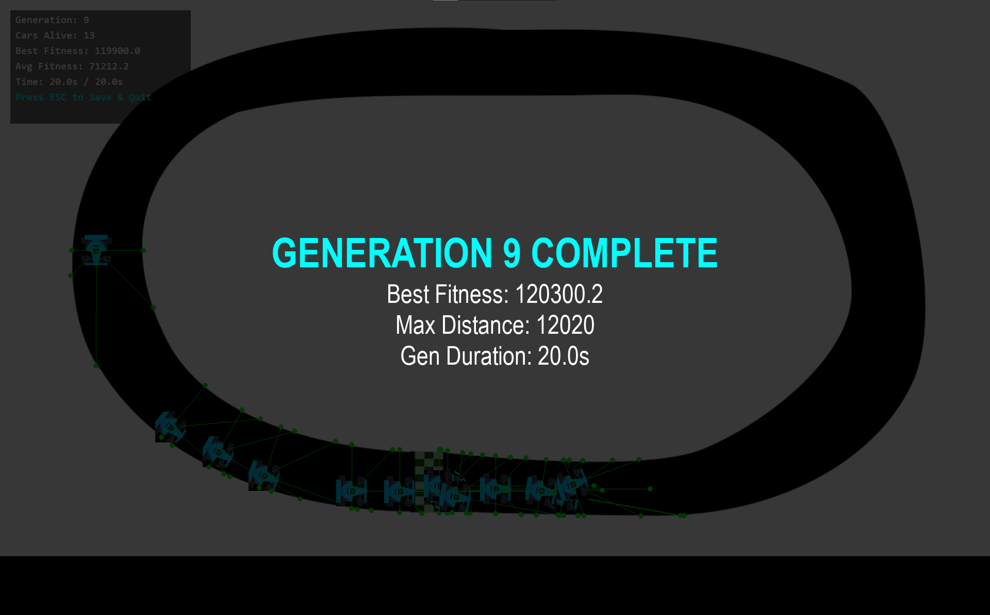

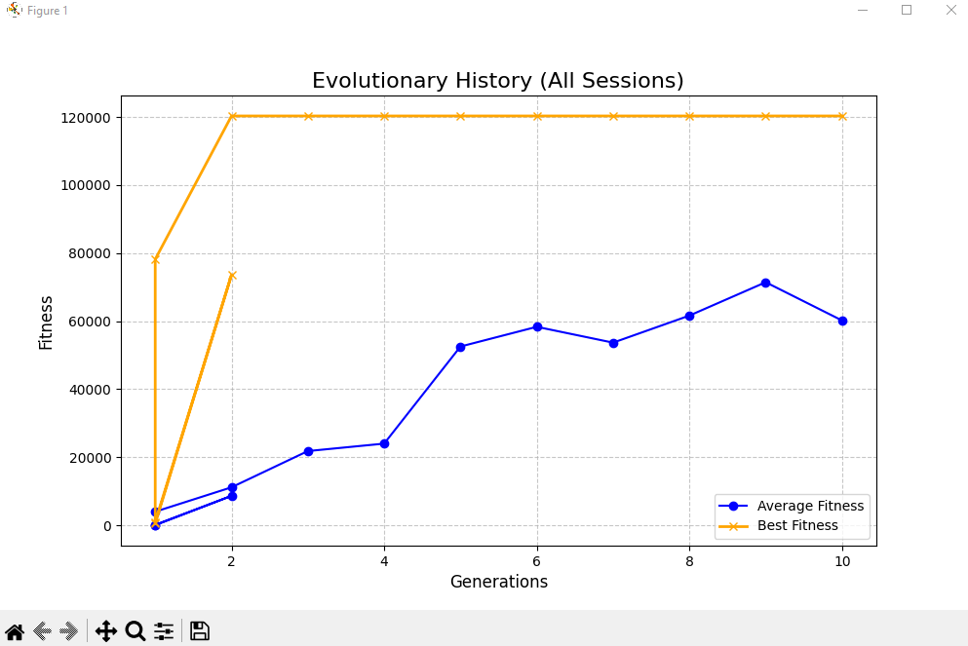
GENERATION 1-5 VS 5-10, as graph’s BLUE line is showing the average fitness (distance covered – time penalty) improved drastically after 6-7 GENERATIONS.

CONCLUSION
The project successfully demonstrates the power of evolutionary algorithms in control systems. By using 6 radar sensors as inputs and mapping them to 4 directional outputs, the cars evolved from random chaos to smooth navigation within just a few generations.
The addition of the Pickle save system ensures that this progress is never lost, allowing for the development of "Super Driver" AI over extended periods. Future improvements could include dynamic obstacles or varying speed limits to further test the neural network's adaptability.

